What Is Economics?

ECONOMICS is the study of how people allocate scarce resources, in order to satisfy unlimited wants. In other words it is about how people make choices.

Note the word Study. This means the term Economics refers to the discipline itself. Later we will go into how economists go about studying economic activities. For now let's continue with the definition.

Note the word People. Oftentimes economics is viewed to be a sub discipline in the field of business. However, unlike business, the focus in economics is more on people themselves and the social systems involved in production, distribution and consumption. As one noted professor of mine said, "Economics is the queen of the social sciences".

Note the word Resources. What are resources? Resources are the materials we have available to produce things with. In economics we have four general categories of resources.
Land - This resource covers all natural resources. It is anything that is above, below, or grown on the land. It is the land area itself. It also includes sunshine, space, clean air and the oceans.
Labor - This resource includes not just the work time put into production activities but also all that is embodied in that labor. This is what is referred to as Human Capital or the education, experience and training that someone brings to their labor.
Physical Capital - These are man made resources and it includes machines, tools, office buildings, roads, and factories.
Entrepreneurship - Oftentimes economists would consider this as a form of labor, but here we are going to give it a separate category because it is such an essential ingredient. Entrepreneurship refers to that ability to organize the other resources and make them productive.

Note the word Wants. Why would economists study how people satisfy wants and not needs? After all some 30% of all the children born today will never have a permanent shelter. With so much need in the world, it would seem that economists would focus on that instead.
Consider these Venn diagrams.


Which of the diagrams do you think best depicts the relationship between these two words?
Is the category of wants independent of the category of needs? Can you think of a need that is not a want and a want that is not a need?
You will probably find that the third diagram that shows that all needs are wants but not all wants are needs, comes closest.
This is one reason why economists focus on wants. The other reason is because people define what they consider to be a need differently from time to time and place to place. Those of you who have moved out of the home you grew up in have probably found that those things that you thought that you couldn't live without before leaving home, became a luxury after.

Note the two words Scarce and Unlimited. It is these two words that the whole definition revolves around. In fact it is the central reason that there is a discipline called economics. Because resources are Scarce, that is there are not enough to satisfy our wants, since our wants are Unlimited, we must make choices. Economists study economics because we want to make informed choices.

Note the word allocate. Somehow we have to figure out how much of our resources we are going to use to satisfy the different wants as well as decide which wants we are going to satisfy.

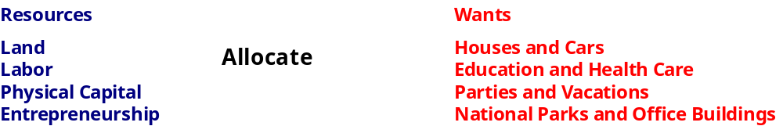

The process by which resources are allocated can take many forms. Think of those times when you were a kid and there was not enough of something to go around. What did you do to determine who got to have it?
Did you go by some rule, such as oldest first?
Maybe a parent stepped in and said that you had to take turns or share it.
Or maybe it was determined by another favorite method, beating up the other person.
Some of you may have made agreements to do jobs for one another, or to earn money.
Whatever method you went by there are comparable methods used in the economies of the world.

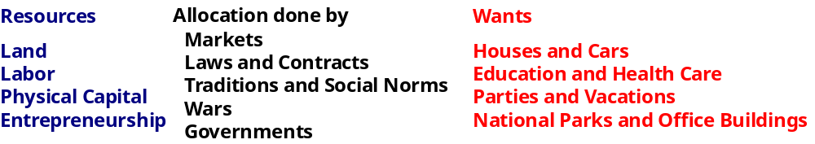

Note the phrase, how people make choices. How is it possible to study something that goes on in people's heads? It is clear that the decision making process cannot be observed directly, therefore we have to draw our conclusions from the actions that result from those decisions. There is a problem however,the same actions or results can come from different decisions. For instance you are taking this class but the reason you decided to take this class can be anything. Maybe you are an avant-garde artist who has decided to take the class just for the experience. Therefore economists make the assumption that economic agents act in their rational self-interest, that is an economic agent would not willingly make a choice that will leave him worse off. This is one of the most fundamental assumptions in economics. Another important assumption is the assumption of ceteris paribus, which means all else held constant.

Now we have come back full circle to the word study. To learn more about how economists go about studying economics read Chapter 2 in your book.

Some Graphing Practice

Economists create models in order to clarify economic processes and ideas. These models can be verbal, mathmatical or graphical models. In this class we will use a lot of graph models, which if you are not used to can be very confusing. So in this section we are going to go over just a couple of key things to keep in mind.

When Ron Howard was talking about making the film 'A Beautiful Mind', he made the observation that mathmaticians were primarily concerned about relationships. This could also be said about most of the models that we will be working with in this class.
It will be easier for you to understand the models if you focus on the shape and direction of the lines in the graph. That is because the shape and direction of the lines will tell you a lot about the relationship between the variable on the horizontal axis and the variable on the vertical axis.

To start the models we will use in this class will begin with the upper right quadrant of the cartesian number plane. That means that all variables will be positive with only a few exceptions.
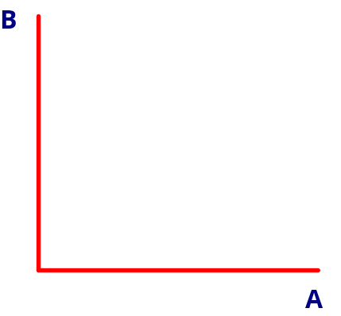

Look at the graph below. What can you say about the relationship between A and B? Note the downward slope. Whenever a graph has a downward slope from left to right, that is going to indicate that there is an inverse relationship between the two variables. In other words if A increases then B will decrease and vice versa.

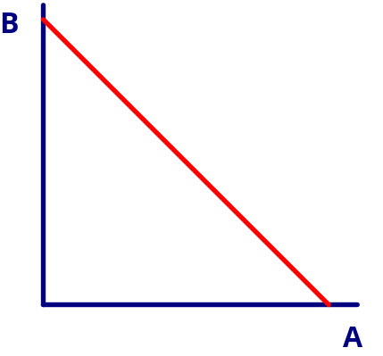
Is there anything else that you can say about the relationship between A and B in the graph above? Is the fact that it is a straight line significant? If the graph is of a straight line then we know that the change in B/change in A = constant.

Now consider the graph below.
What can you say about the relationship between A and B in this graph?
Again it slopes downward from left to right so we know that there is an inverse relationship between A and B in this graph as well.

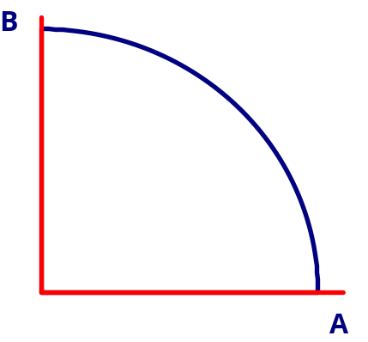

However, we know that there is something different about the relationship between A and B in this graph. Unlike the first graph above, this one has a curved line instead of a straight line. From this we can say that the change in B/change in A is NOT constant. In fact as A increases B gets smaller at a faster and faster rate. We are going to see that this will be an important part of the relationship that we are going to describe in our first model.

